Associate Exit Flow

*(Associate Exit Flow – Guide)*

This document describes in detail the **Associate Exit Flow**. This portal has different user roles like (*Associate, Program Manager, HRM- Human Resource Manager, HRA, Team Lead, Manager-IT department, Manager-Admin department, Manager-Finance department, Manager-Training department).*

1. **KT Plan by Team Lead**
2. Once HRM accepts the resignation. Team lead can start the KT plan.
3. Team Lead needs to login to the portal (Via single sign-on) with SenecaGlobal email Id. After authentication, Team lead will be redirected to Dashboard page. In Team lead Dashboard, the Status of the associate who submitted the Resignation will be shown as ‘**Resignation In Progress.’**
4. 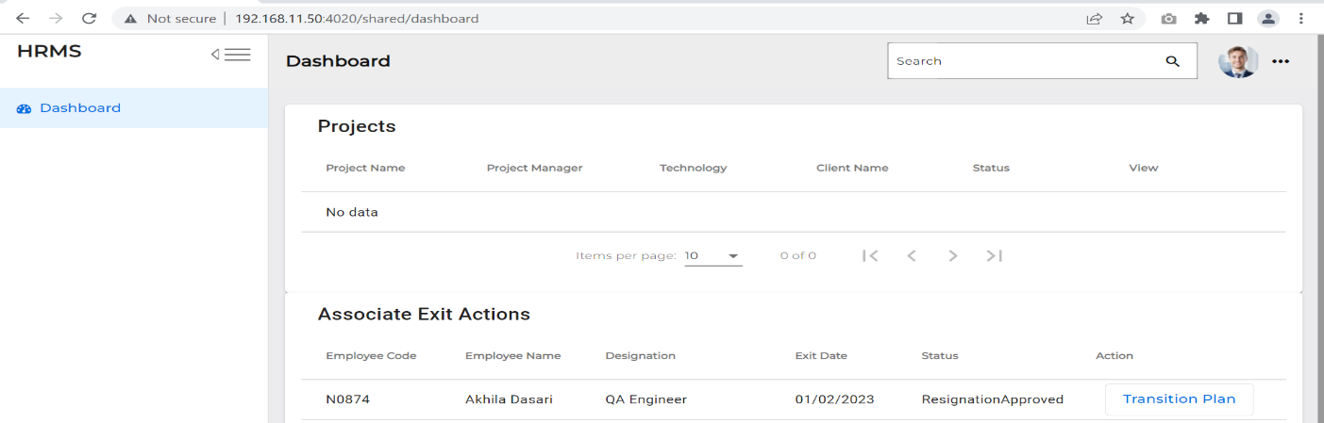Action Button Contains the Transition Plan.
5. 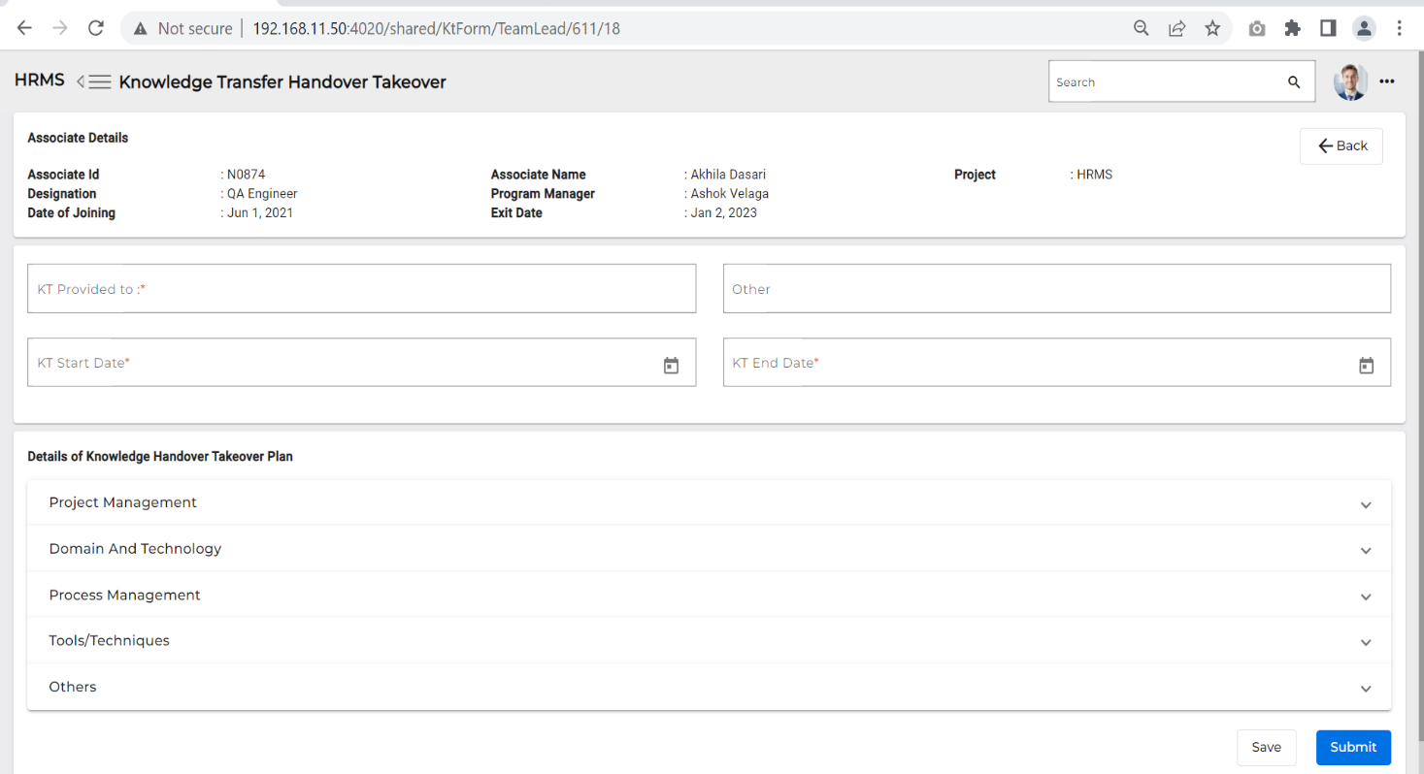If Team Lead clicks on **Transition plan** it is redirected to Knowledge Transfer Handover Takeover screen.
6. Team Lead needs to enter all the below fields in the Knowledge Transfer Handover Takeover page, which are Mandatory.

* KT Start Date
* KT End Date
* KT Provided To
* Others (not mandatory field)
* Details of Knowledge handover takeover plan

1. If Team Lead clicks on **Submit** button, ‘**KT plan’** is submitted to the Associate and **Submit** button gets disabled.
2. After submitting the KT, TL still can add/modify KT plan and click on **Submit** button.
3. Updated KT plan will be reflected on the associate’s screen.

* **An email is triggered to the associate, and the status is changed to ‘KT plan in progress’**

1. **Team Lead (KT Review and Approval)**
2. Once KT plan defined and submitted to associate
3. Associate give KT then changes the status to completed for each task Clicks on Submit button
4. Team Lead needs to login to the portal (Via single sign-on) with SenecaGlobal email Id. After authentication, Team Lead will be redirected to the Dashboard page. In the Team lead Dashboard, the status of the associate who submitted the KT plan changes to **‘KT plan Submitted.’**
5. If Associate KT plan’s status is ‘**KT plan submitted’** then the Team lead needs to click on the ‘**Transition plan’** button.

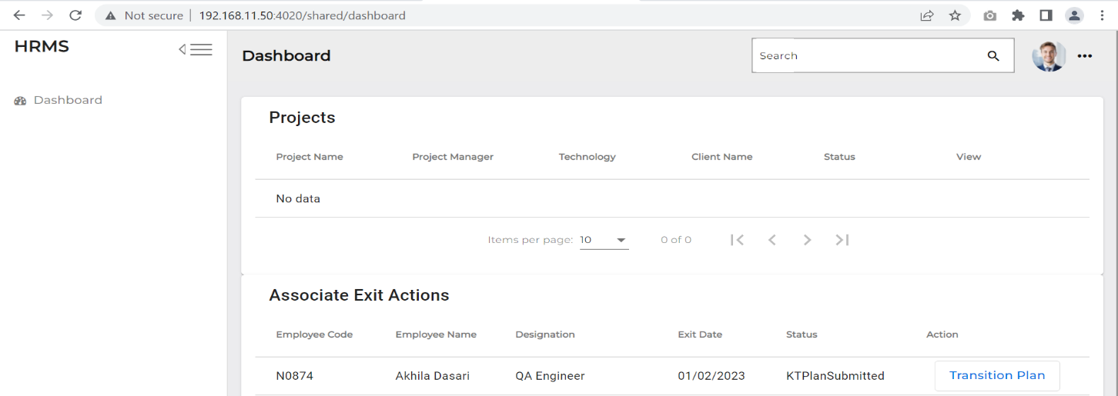

1. Once the Team Lead clicks the Transition plan button it is redirected to Knowledge Transfer Handover Takeover screen.

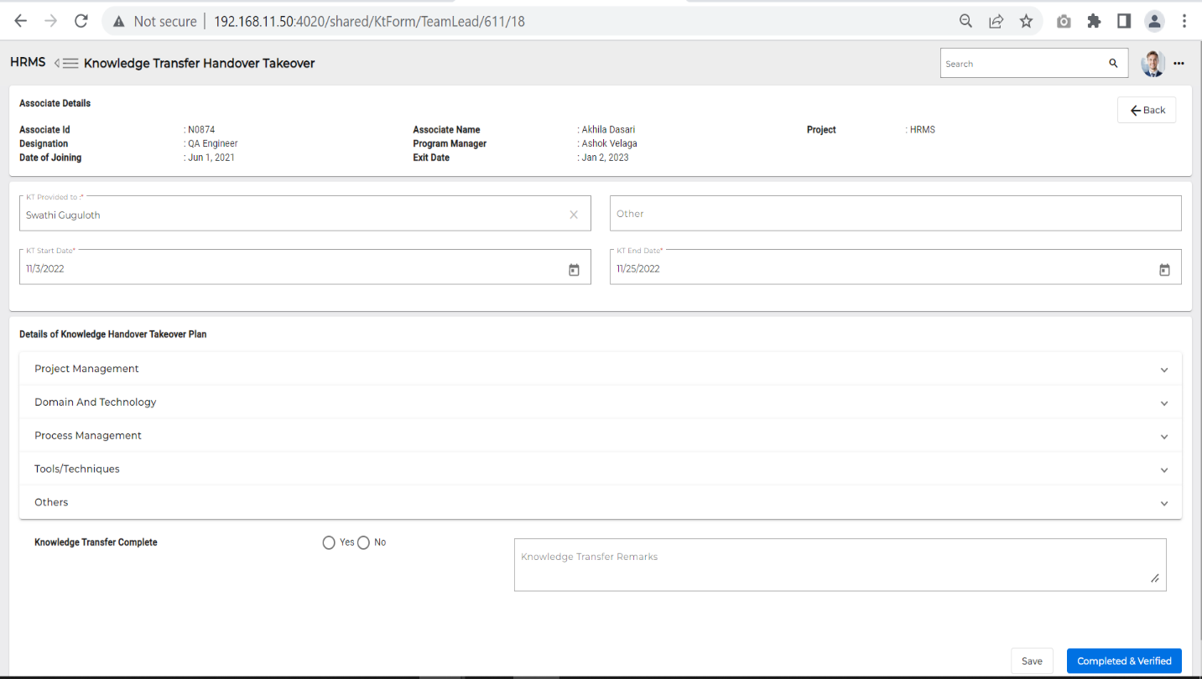

1. ‘**Knowledge Transfer complete’** has two radio buttons with Yes and No.
2. If Team lead clicks on ‘**Completed & verified’**, the associate’s record is removed from the Team Lead’s Dashboard Status changes to ‘Resignation in Progress’
3. Associate dashboard the status is changed to ‘**KT Plan completed’**.